A

Technical Report on

## AUTOMATED BOREWELL SYSTEM

*Submitted to CMR Institute of Technology in the partial fulfillment of the requirement of*

# Social Innovation Lab

Of

# II B.Tech I- Semester

in

# ECE DEPARTMENT

Submitted by

**K.MAHIDHAR (20R01A04L4)**

**G.VINAY (20R01A04K9)**

**B.NIKHIL NAIK (20R01A04J9)**

**N.VINAY KUMAR (20R01A04N1)**

**P.SHARATH (20R01A04N9)**

**M.VAIBHAV REDDY (20R01A04M3)**

***Under the esteemed guidance of***

*Mr. T. Nagaraja Kumar Assistant Professor*

**CMR INSTITUTE OF TECHNOLOGY**

**(UGC-AUTONOMOUS)**

(Approved by AICTE, Permanently Affiliated to JNTU Hyderabad, Accredited by NBA, Accredited by NAAC with ‘ A’ Grade)

Kandlakoya (V), Medchal Road, Hyderabad – 501 401

**2020-2021**

**`**

***Department of ECE***

Certificate

This is to certify that the technical report entitled“***AUTOMATED BOREWELL SYSTEM***” is the bonafidework done and submitted by

**K.MAHIDHAR (20R01A04L4)**

**G.VINAY (20R01A04K9)**

**B.NIKHIL NAIK (20R01A04J9)**

**N.VINAY KUMAR (20R01A04N1)**

**P.SHARATH (20R01A04N9**

**M.VAIBHAV REDDY (20R01A04M3)**

towards the partial fulfillment of the requirement of Social Innovation (SIL) Laboratory of **II B. Tech I-Semester** in **ECE** is a record of bonafide work carried out by them during the period **SEP 2021 to JAN 2022.**

|  |  |  |
| --- | --- | --- |
| **Guide** | **Co- Ordinator** | **Head of Department** |
| ***Mr. T. Nagaraja Kumar*** | ***Mr.Ramakrishna*** | ***Dr. k.Niaranjan*** |
| ***(Assistant professor)*** |  | ***ECE Department*** |
| ***CSE Department*** |  |  |

**INDEX**

|  |  |  |
| --- | --- | --- |
|  | **INDEX** |  |
| **Topics** |  | **Page No** |
| **CHAPTER-I** | **INTRODUCTION** | **1-2** |
| **CHAPTER -II** | **Empathize** | **3** |
| **CHAPTER -III** | **Define** | **4-5** |
| **CHAPTER -IV** | **Ideate** | **6-7** |
| **CHAPTER -V** | **Prototype** | **8-15** |
| **CHAPTER -VI** | **Test** | **16** |
| **CHAPTER -VII** | **References** | **17** |

**1. INTRODUCTION**

### WHAT IS SOCIAL INNOVATION?

The term ‘social innovation ’once rarely heard is ,now often used to describe a whole variety of things that fall into general categories of being both new and good.It’s understandable that the phrase has become popular-we get excited and hopeful when it seems possible for real change to happen in the world.

Social innovation refers to the Design and implementation of new solutions that imply conceptual ,process ,product or organisational change which ultimately aim to improve the welfare and wellbeing of individual communities

Social innovation is not a new concept and should not be considered similar to other definitions, such as social entrepreneurship, creativity or invention, improvement or change. 'As with innovation in technology or business, social innovation is distinct from ‘improvement’ or ‘change’ and from ‘creativity’ and ‘invention’. These last two are both crucial to innovation but overlook the important stages of implementation and diffusion which make new ideas useful.

## What is design thinking process?

Design Thinking is a design methodology that provides a solution-based approach to solving problems. It’s extremely useful in tackling complex

problems that are ill-defined or unknown, by understanding the human needs involved, by re-framing the problem in human-centric ways, by creating many ideas in brainstorming sessions, and by adopting a hands-on approach in prototyping and testing. Understanding these five stages of Design Thinking will empower anyone to apply the Design Thinking methods in order to solve complex problems that occur around us — in our companies, in our countries, and even on the scale of our planet.

Design thinking originally came about as a way of teaching engineers how to approach problems creatively, like designers do. One of the first people to write about design thinking was John E. Arnold, professor of mechanical engineering at Stanford University.

## The five stages of design thinking:

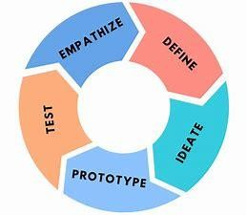

1. Empathize-ľhe Design ľhinking píocess staíts with empathy. In oídeí to cíeate desiíable píoducts and seívices, you need to undeístand who youí useís aíe and what they need.
2. Define- In the second stage of the Design ľhinking píocess, you’ll define the useí píoblem that you want to solve.
3. Ideate.-ľhe thiíd stage in the Design ľhinking píocess consists of ideation oí geneíating ideas. ...
4. Píototype- In the fouíth stage of the Design ľhinking píocess, you’ll tuín youí ideas fíom stage thíee into píototypes.
5. ľest -ľhe fifth step in the Design ľhinking píocess is dedicated to testing: putting youí píototypes in fíont of íeal useís and seeing how they get on.

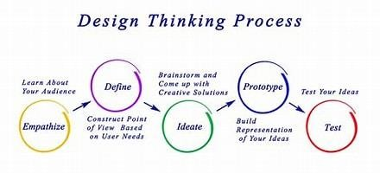

* 1. **Empathize**

The first stage of the Design Thinking process is to gain an empathic understanding of the problem you are trying to solve. This involves consulting experts to find out more about the area of concern through observing, engaging and empathizing with people to understand their experiences and motivations, as well as immersing yourself in the physical environment so you can gain a deeper personal understanding of the issues

involved. Empathy is crucial to a human-centered design process such as Design Thinking, and empathy allows design thinkers to set aside their own assumptions about the world in order to gain insight into users and their needs.

We have collected information from various sources like conducting surveys among the people about their problems as they are facing right now and interviewing people, reading novels from various books ,collecting information from the internet.

As our team has conducted a survey among the people at the current problems they are facing we have got many problems to be listed .In those information we have found many valid problems as they are facing in the day to day life and the collected information have been segregated accordingly.

We have shortlisted few problems which are being affected by the most people in the society .

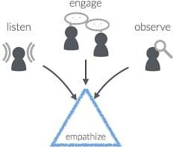

So , have chosen one of the problem that is the air pollution is the major problem from the shortlisted problems that many people are facing and its causes wealth lose , human lose and many more .

# Survey on Air pollution:

**Team member 1:**Are you,facing any problem with unknown quantity of in water in bore well

**Person1:**yes,there is a problem of unknown qantity of water.

**Team member 1**: **What is the depth of boíewell foí agíicultuíal puípose?**

Person1:We drilled 7 inch borewell for agricultural purpose. Hit the rock at 66 feet. Encountered 3 inches of water at 100 feet. After 110 feet loose soil encountered.

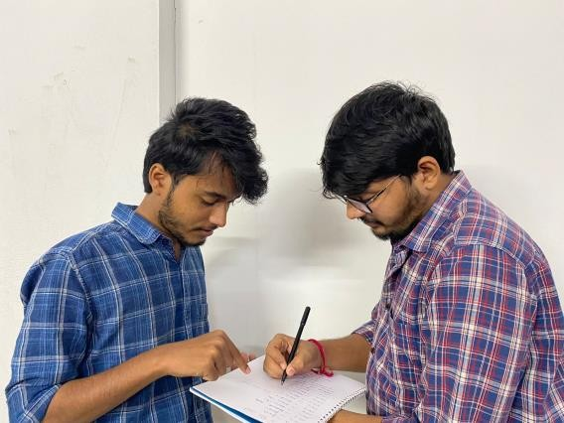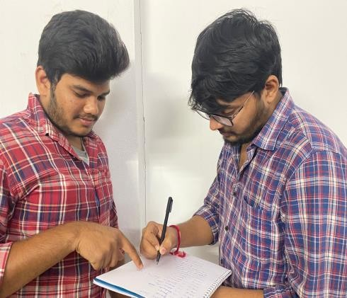

**ľeam membeí 2:What is the diffeíence between a boíewell and a tubewell?**

Peíson 2: Boíewells & tubewells, aíe veíy similaí. Both aíe basically veítical díilled wells, boíed into an undeígíound aquifeí in the eaíths suíface, to extíact wateí foí vaíious puíposes

### Team member 2: Is there any criteria to measure unknown quantity of water

Person 2:We can find the water level in a borewell from the ground by time calculating the time taken for a very small stone (0.5 inch) to strike the water surface.

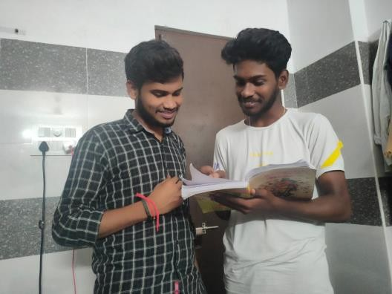

* + 1. **Define**

In this define stage, we have defined the problem statement accordingly to our problem. According to the scenario as we have collected information in the empathy stage we have defined the problem statement as “AUTOMATED BOREWELL SYSTEM”

**3.1. Problem Statement**

In some seasons we can’t find the depth of the water in the ground level ,due to unknown Quantity of water majorly motor issues facing by the farmers.To over come this problem We found a“AUTOMATED BOREWELL SYSTEM”.

* 1. **Objective:**
     + The main motto of our project is that to reduce the Motor issues in the Agriculture Sector.
     + To combine advanced detection technologies to known the unknown quantity of water level, capabilities to provide low cost comprehensive monitoring.
     + Energy nither be Created nor be Destroyed ,in bore well the water level sensor should be resistant accordingly climatic condiations like heat and cold.

## Ideate

In this design thinking process we have ideate as the next stage and we have come up with a solution according to the above problem statement as we have mentioned.

Basically our model can be divided into two parts one is the AUMOATED BOREWELL SYSTEM and other is the monitoring Unknown quantity of water. As we have gone through the need statement with literature review .so that we can know what exactly our machine must contain .By considering the drawbacks we designed a machine that consume electricity . It should not be expensive (everyone can afford it ). Its also durable and doesn’t have high maintenance .Its easily portable.

We have to make a model of borewll with hard cardboard ,and make a square shape . And we want compents like water level sensor ,pipe ,12v DC motor,12 v recharge battery, switch, Ardunio Uno ,DC connector , 5V Relay

,Buzzer.connecting wires. By connecting all the current connections to the on and off switch to the battery at the opening of square cardboard the automated borewell is will be ready to work

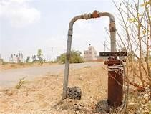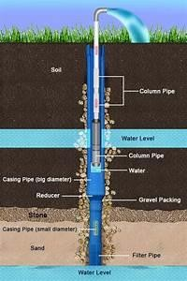

**FLOW CHART :**

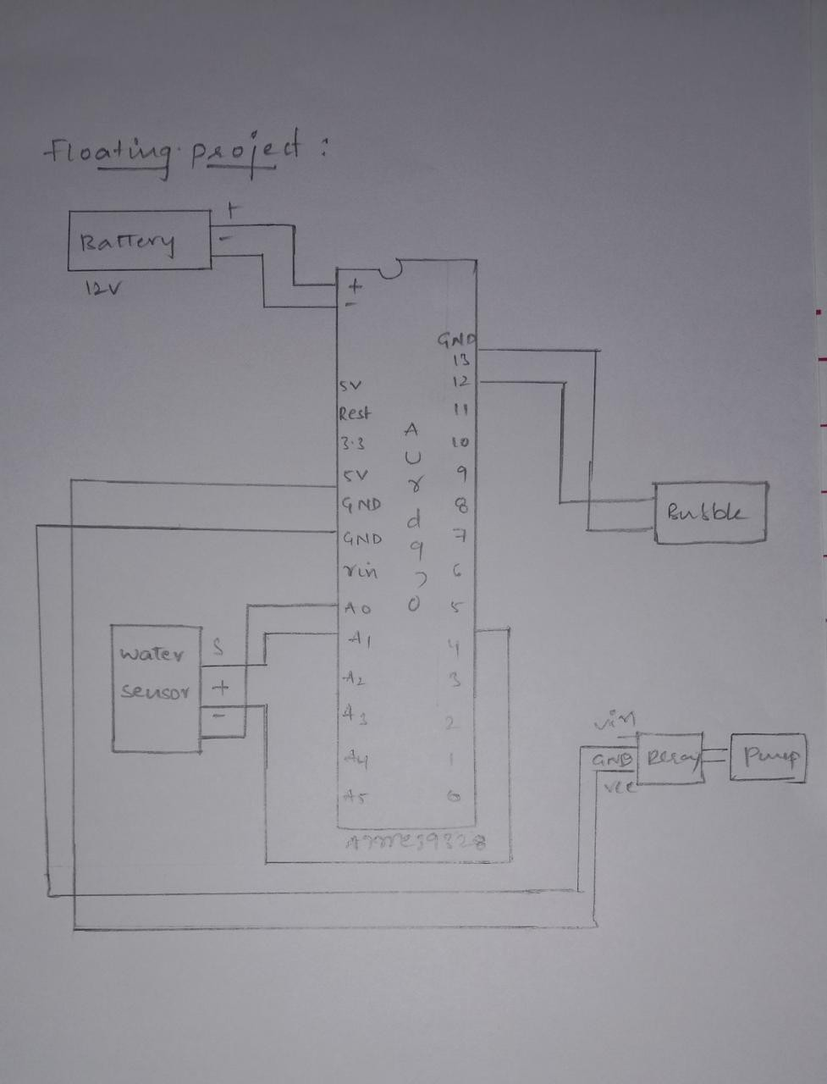

## Prototype

The next step is making a prototype , that is for making a prototype we require components like

**COMPONENTS REQUIREMENTS :-**

1. water level sensor
2. 12 V dc motor
3. 5v relay.
4. Switch .
5. Arduino UNO.
6. Buzzer.
7. 12v rechargeable battery.
8. 12v power adpater.

**TOTAL COST OF OUR PROJECT IS =Rs 2500\-**

**Arduino Uno:**

**Product Description:** Arduino is an open source computer hardware and software company, project, and user community that designs and manufactures single-board microcontrollers and microcontroller kits for building digital devices and interactive objects that can sense and control objects in the physical world. The boards are equipped with sets of digital and analog input/output (I/O) pins that may be interfaced to various expansion boards (shields) and other circuits. The boards feature serial communications interfaces, including Universal Serial Bus (USB) on some models.

The microcontrollers are typically programmed using a dialect of features from the programming languages C and C++.

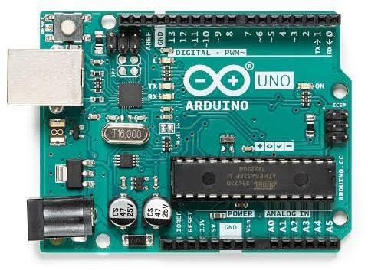

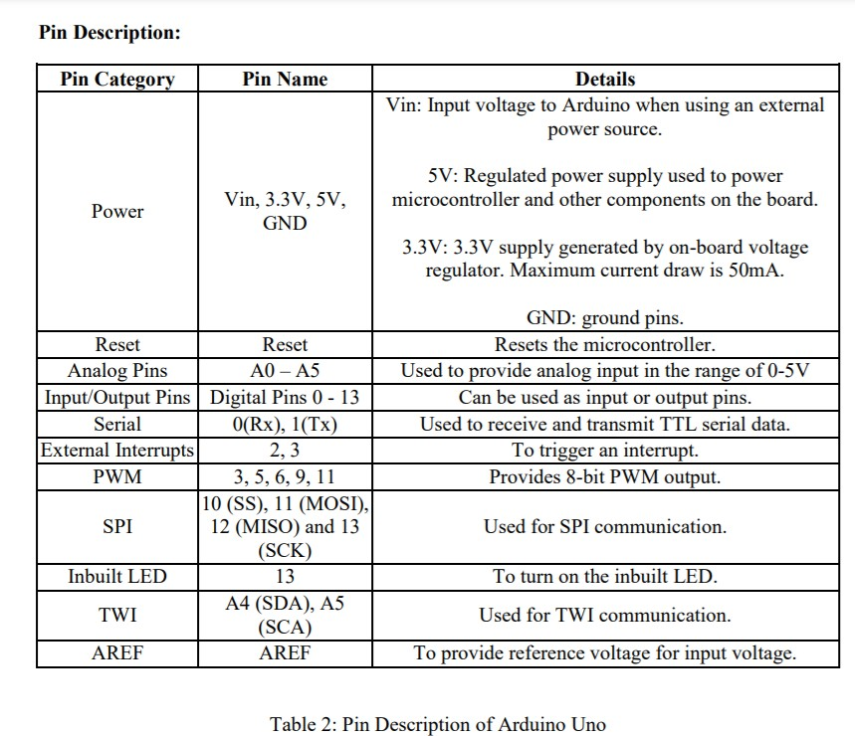

**ON AND OFF SWITCH:-**

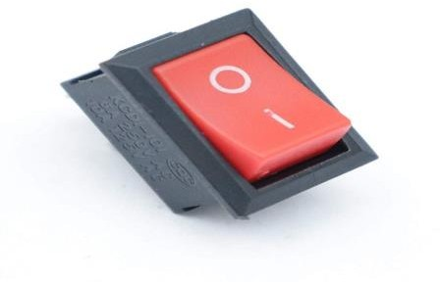

The well-known on/off power symbol was the result of the logical evolution in user interface design. Originally, most early power controls consisted of switches that were toggled between two states demarcated by the words On and Off. As technology became more ubiquitous, these English words were replaced with the universal symbols line "|" and circle "o" to bypass language barriers. This standard is still used on toggle power switches.

The symbol for the standby button was created by superimposing the symbols "|" and "o"; however, it is commonly interpreted as the numerals "0" and "1". Yet the

Motor pump :

Most RV water pumps run using the RV's 12-volt battery. ... This is a 12v RV water pressure pump that can also be adapted for marine, filtration, and solar water systems. It can flow water pressure ranging from 17 to 55 psi, thanks to internal bypass technology that reduces cycling controlled by a switch.

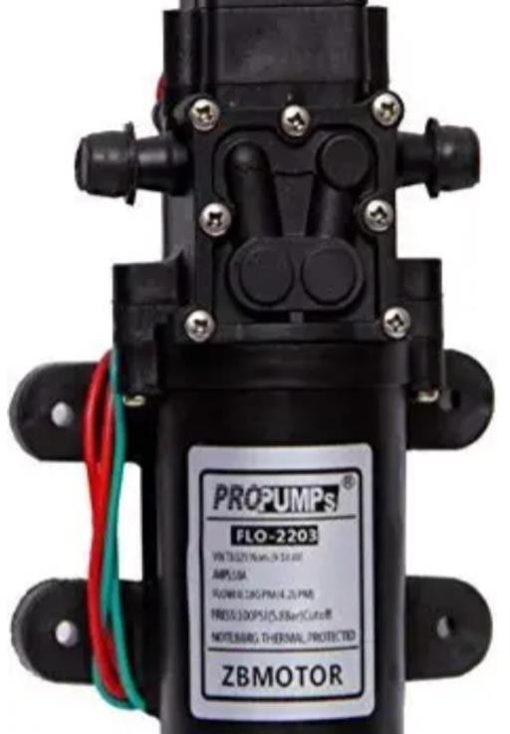

Relay :

**A relay is an electrically operated or electromechanical switch composed of an electromagnet, an armature, a spring and a set of electrical contacts. The electromagnetic switch is operated by a small electric current that turns a larger current on or off by either releasing or retracting the armature contact, thereby cutting or completing the circuit. Relays are necessary when there must be electrical isolation between controlled and control circuits, or when multiple circuits need to be controlled by a single signal.**

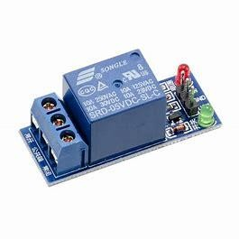

**Water level sensor:**

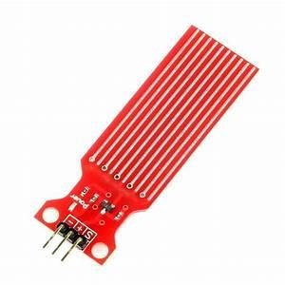Principle of Water Level Indicator The working principle of a water level indicator is actually quite simple. Water level indicators work by using sensor probes to indicate water levels in a storage tank. These probes send information back to the control panel to trigger an alarm or indicator.

Battery:

**12V lithium battery is a lithium battery pack composed of 3 or 4 lithium batteries in series. The capacity of the battery is determined by the capacity of the single cell and the number of cells in parallel. It is a new kind of safe and environmental rechargeable battery.**

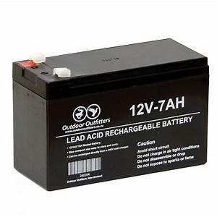

Buzzer:

**The working voltage of the electromagnetic buzzer can be 1.5-24 V, and the working voltage range of the piezoelectric buzzer can be 3v-220v. However, under normal circumstances, the working voltage range of the piezoelectric buzzer is recommended to be above 9V to obtain a larger sound.**

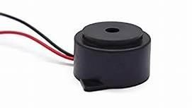

## Prototype Model:

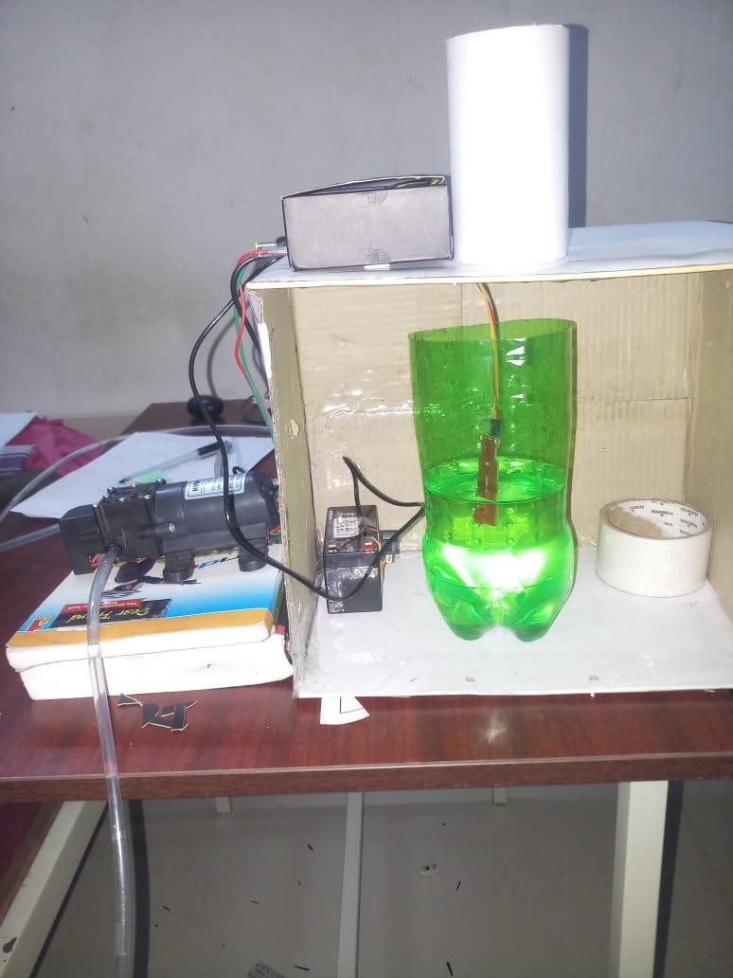

**SOURCE CODE**

#define sensorPower 8

#define led 7

#define buz 13

int val = 0; void setup()

{

Serial.begin(9600);

delay(2000);

// Set to LOW so no power flows through the sensor digitalWrite(sensorPower, LOW);

pinMode(buz, OUTPUT); pinMode(led, OUTPUT); digitalWrite(buz, LOW);

}

int readSensor() {

digitalWrite(sensorPower, HIGH); // Turn the sensor ON delay(10); // wait 10 milliseconds

val = analogRead(sensorPin); // Read the analog value form sensor digitalWrite(sensorPower, LOW); // Turn the sensor OFF

return val; // send current reading

}

void loop()

{

int level = readSensor(); Serial.println(level);

if(level<470 )

{

Serial.println("LOW");

digitalWrite(buz, HIGH); digitalWrite(led,HIGH);

}

delay(2000); if(level>=470 )

{

Serial.println("HIGH"); digitalWrite(buz, LOW); digitalWrite(led, LOW);

}

delay(100);

}

## Test

we have also found errors in uploading the code to the arduino that it is showing compile error. we didn't include the library files to code.so, we installed the libraray file named

<servo.h> in the ardunio software .Then code complied succesfully and done uploading.

Testing the setup ‘n’ number of times will make us to clear all the loop holes which are in it . And the final product efficient and its performance is be good and considerable and other working models.

And while uploading the code make sure you are connected to the port and upload it using the rightarrow.

By our innovation in our project, we can know the ground level of the water. To make a AUTOMATED BOREWELL SYSTEM which can be affordable to everyone and has low maintenance. we have learnt much from this topic or project which we took up. We have introduced the design and implementation of a low cost borewell system monitoring device . This bore wells along with the monitoring device can be easily manufactured on a large scale for mass production because of its simplicity and ease of design. And we hope this will help the society for over coming problems like unknown water ground level.

we have tested several times that the motor fills with the air to over come these problems we have used DC motor to pull the water from the borewell and passes through the outlet pipe with pressure and comes out. Hence by this we can know the under ground water by using automated borewell system .

### REFERENCES:-

* *https://en.wikipedia.org/wiki/Arduino#/media/File:UnoConnections.jpg*
* [*http://www.circuitbasics.com/how-to-set-up-the-dht11-humidity-sensor-on-an-*](http://www.circuitbasics.com/how-to-set-up-the-dht11-humidity-sensor-on-an-arduino/)[*arduino/*](http://www.circuitbasics.com/how-to-set-up-the-dht11-humidity-sensor-on-an-arduino/)
* [*https://playground.arduino.cc/Main/DHT11Lib*](https://playground.arduino.cc/Main/DHT11Lib)
* [*https://www.robot-r-us.com/vmchk/sensor-temp/humid/dht11-temperature-*](https://www.robot-r-us.com/vmchk/sensor-temp/humid/dht11-temperature-and-humiditysensor.html)[*and-humiditysensor.html*](https://www.robot-r-us.com/vmchk/sensor-temp/humid/dht11-temperature-and-humiditysensor.html)
* [*https://electrosome.com/power-supply-design-5v-7805-voltage-regulator/*](https://electrosome.com/power-supply-design-5v-7805-voltage-regulator/)
* [*https://www.epa.gov/air-research/air-monitoring-measuring-and-emissions-*](https://www.epa.gov/air-research/air-monitoring-measuring-and-emissions-research)[*research*](https://www.epa.gov/air-research/air-monitoring-measuring-and-emissions-research)
* [*http://howtomechatronics.com/tutorials/arduino/dht11-dht22-sensors-*](http://howtomechatronics.com/tutorials/arduino/dht11-dht22-sensors-temperature-and-humiditytutorial-using-arduino/)[*temperature-and-humiditytutorial-using-arduino/*](http://howtomechatronics.com/tutorials/arduino/dht11-dht22-sensors-temperature-and-humiditytutorial-using-arduino/)
* [*https://www.elprocus.com/ever-wondered-lcd-works/*](https://www.elprocus.com/ever-wondered-lcd-works/)
* [*https://www.google.co.in/search?q=dht11&client=firefox-*](https://www.google.co.in/search?q=dht11&client=firefox-a&rls=org.mozilla%3AenUS%3Aofficial&channel=np&dcr=0&source=lnms&tbm=isch&sa=X&ved=0ahUKEwj8sMu0oPXAhUlTY8KHW8wB6kQ_AUICigB&biw=1366&bih=598)[*a&rls=org.mozilla:enUS:official&channel=np&dcr=0&source=lnms&tbm=i*](https://www.google.co.in/search?q=dht11&client=firefox-a&rls=org.mozilla%3AenUS%3Aofficial&channel=np&dcr=0&source=lnms&tbm=isch&sa=X&ved=0ahUKEwj8sMu0oPXAhUlTY8KHW8wB6kQ_AUICigB&biw=1366&bih=598)[*sch&sa=X&ved=0ahUKEwj8sMu0oPXAhUlTY8KHW8wB6kQ_AUICigB&bi*](https://www.google.co.in/search?q=dht11&client=firefox-a&rls=org.mozilla%3AenUS%3Aofficial&channel=np&dcr=0&source=lnms&tbm=isch&sa=X&ved=0ahUKEwj8sMu0oPXAhUlTY8KHW8wB6kQ_AUICigB&biw=1366&bih=598)[*w=1366&bih=598*](https://www.google.co.in/search?q=dht11&client=firefox-a&rls=org.mozilla%3AenUS%3Aofficial&channel=np&dcr=0&source=lnms&tbm=isch&sa=X&ved=0ahUKEwj8sMu0oPXAhUlTY8KHW8wB6kQ_AUICigB&biw=1366&bih=598) *.*